Boiler commissioning procedure and maintenance for gasification boilers series Orligno 200

1. Fill in „Boiler commissioning procedure” , pay an attention on your personal data and the boiler specification.

2. Check the chimney draft:

Orlan/Orligno 200 18 kW 8- 15 Pa
Orlan /Orligno 200 25 kW 10-15 Pa
Orlan/Orligno 200 40 kW 24-28 Pa
Orlan /Orligno 200 60 kW 13-15 Pa
Orlan/Orligno 200 80 kw – 20- 27 Pa
Orlan 96 kw 20- 25 Pa
Orlan 130 kw 20- 25 Pa

In case of too large chimney draft, draft regulator should be used. If the chimney draft is to little it is necessary to rebuild the chimney or to install supporting fan (chimney exhaust fan).

3. Check the section( hydraulic diameter of chimney cannot be smaller than the diameter of boiler flue ), chimney tightness and the connection of a chimney with a boiler flue.
Connecting flue pipe with chimney should go up with at least 5º angle to lower pressure loss.
Boiler should be connected with chimney with shortest possible section but with required minimal distance to boiler-room’s wall.

4. Ensure water to the boiler and then check tightness of hydraulic connections and the boiler body.
In installation with forced flow of water; system need to be adjusted in case of lack of power – need to be assured minimal theoretical power collection from boiler under gravitation:

Orlan/Orligno 200 18 kw - 4 kw
Orlan /Orligno 200 25 kW – 5 kw
Orlan/Orligno 200 40 kw – 8 kw
Orlan /Orligno 200 60 kw – 15 kw
Orlan/Orligno 200 80 kw – 25 kw
Orlan 96 kw – 32 kW
Orlan 130 kw - 50 kW

5. Control correctness of electrical connections accordingly to the point “Electrical connections”

6. CONTROL THE CORRECT AIR SETTINGS:

6a). Control primary air settings:
- remove fan cover and fan holding plate
- unscrew the nut from the primary air baffle
- set up the primary air baffle
- screw in the nut holding the primary air baffle.

Orlan/Orligno 200 18 kw 9 mm
Orlan /Orligno 200 25 kW 9 mm
Orlan/Orligno 200 40 kw 16 mm
Orlan /Orligno 200 60 kw 9 mm
Orlan/Orligno 200 80 kw 9 mm
Orlan 96 kw 22 mm
Orlan 130 kw 22 mm

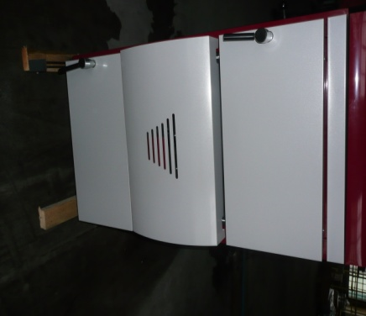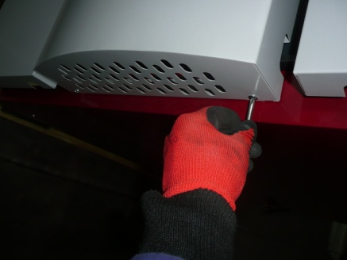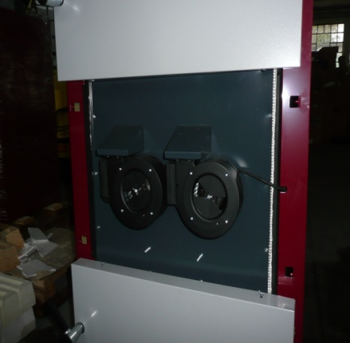

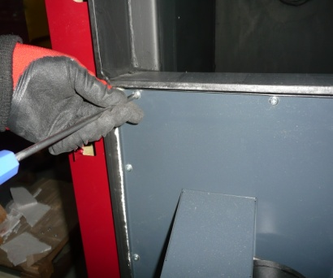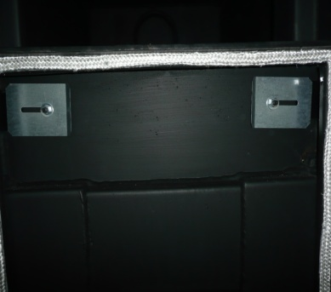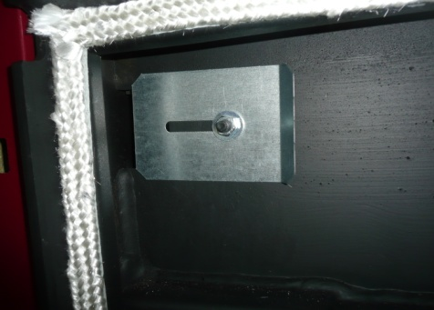

Caution! REGULATION MUST BE DONE ON BOTH BAFFLES

6b). Control secondary air settings :
- remove the fan casing
- loosen the nut for regulation screw
- screw in tightly regulation screw
- unscrew number of full rotations acc. to the list below and then block it with the nut

Orlan/Orligno 200 18 kw 3 rotations
Orlan /Orligno 200 25 kW 3 rotations
Orlan/Orligno 200 40 kw 6 rotations
Orlan /Orligno 200 60 kw 4.5 rotations
Orlan/Orligno 200 80 kw 4.5 r rotations
Orlan 96 kw 10 rotations
Orlan 130 kw 10 rotations
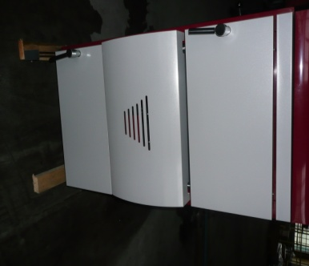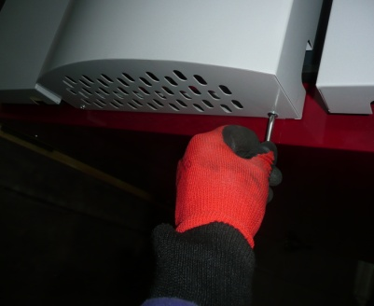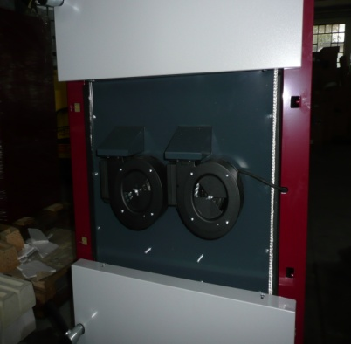

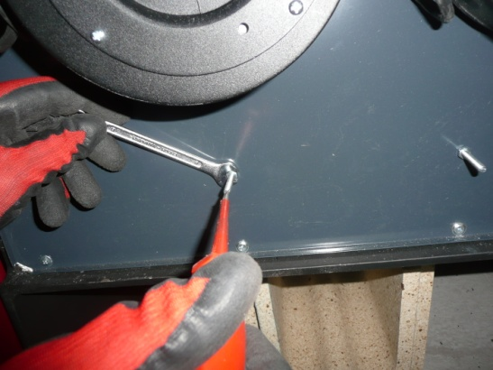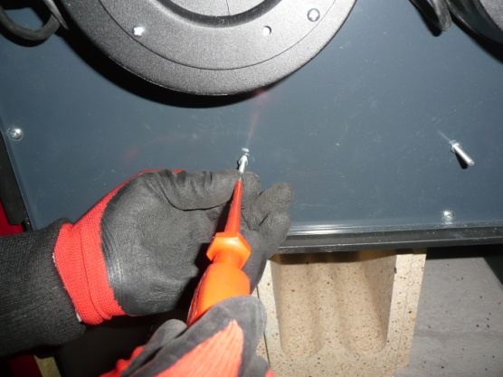

Caution! REGULATION MUST BE DONE ON BOTH SCREWS .

6c). Check opening of the fan ( fans) shutter ( shutters) accordingly to the below:

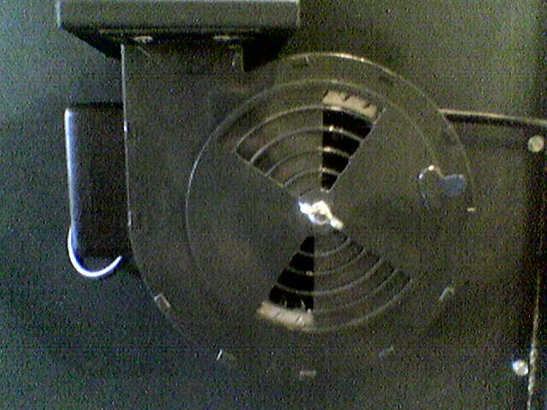
- for 18 kW boiler- open the shutter 30%

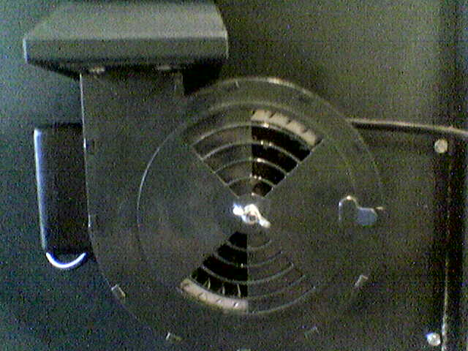
- for 25 kW boiler- open the shutter 50%

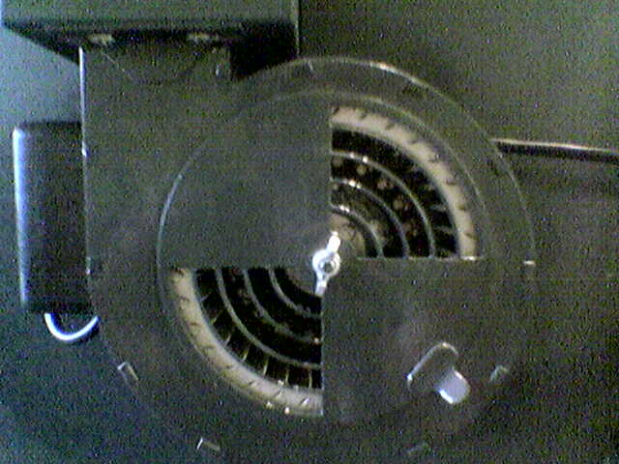
- for 40 kW boiler- open the shutter 75%

- for 60 kW boiler- open the shutter 50%

- for 80 kW boiler- open the shutter 100%

- for 96 kW boiler- open the shutter 100%

- for 130 kW boiler- open the shutter 100%

If shutter is not correctly set then loosen the wing nut and set the shutter in right position:

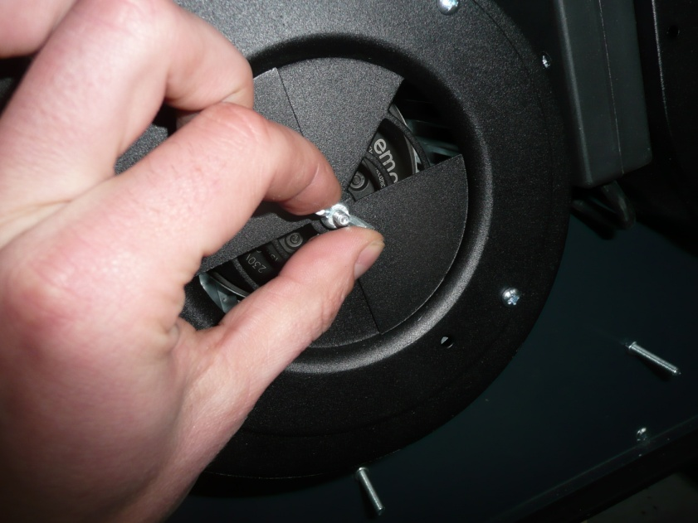

6d) CHECK BEFORE FIRST LIGHTNING UP IF THERE’S FREE FLOW OF AIR FROM PRIMARY AIR CHANNELS AND SECONDARY AIR HOLES IN NOZZLE BY TURNING ON THE FAN ON THE CONTROLLER.

7. Check the number and positioning of U firebricks in the bottom chamber (they must be placed along the chamber under the nozzle openings as shown on 2nd photo):

Orlan/Orligno 200 18 kw 2 pcs
Orlan /Orligno 200 25 kW 2 pcs
Orlan/Orligno 200 40 kw 2 pcs
Orlan /Orligno 200 60 kw 3 pcs
Orlan/Orligno 200 80 kw 4 pcs
Orlan 96 kw 4 pcs
Orlan 130 kw 4 pcs

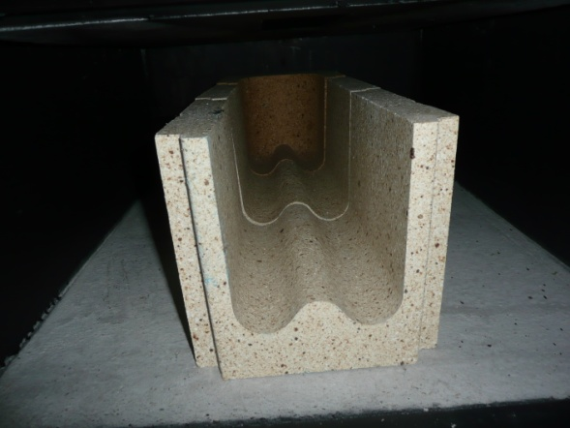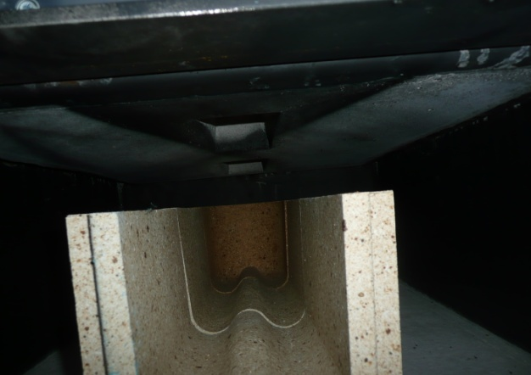

8. Check all threaded parts (hinges, door handles) if they’re greased with any mechanical grease (should be greased once a 2-3 weeks):

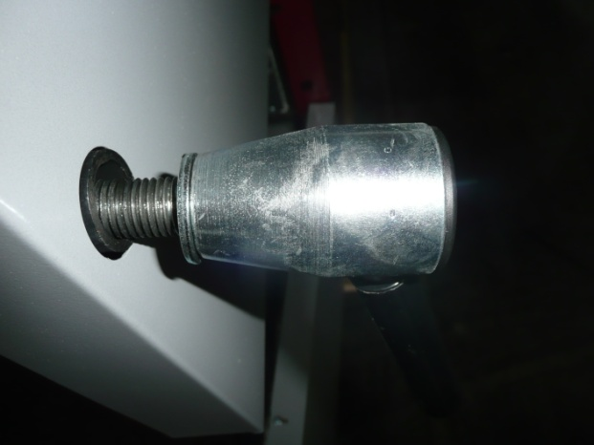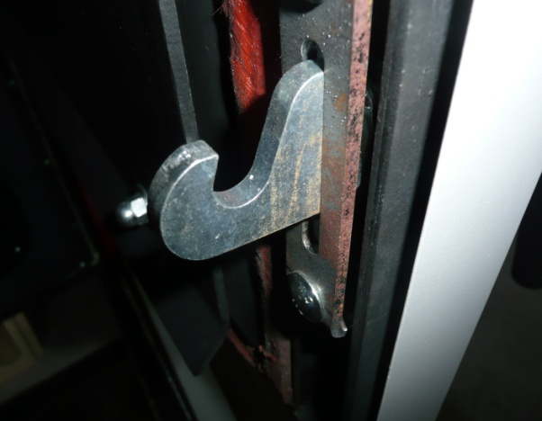

8.Light the boiler according to the point „Lighting” from the manual.

9. In case if fumes get out of the boiler door it is necessary to put out the boiler and start the boiler door and the hinges regulation. Both upper and lower door are fastened with two hinges. When the hinges are regulated the door must be taken off with fast , energetic uplifting.
Next start regulation of the hinges accordingly to attached file.

Caution! After the boiler door regulation it can be necessary to use force while closing door , after correct rope placing ( after few closings of the boiler door) closing will be much easier.

After –heating season maintenance activities:

It is necessary to prepare boiler for upcoming heating season in order to assure trouble-free boiler usage.
It is recommended to commission boiler inspection to qualified serviceman of boiler distributor. This will guarantee professional and skilled boiler preparation based on long-term experience of boiler producer.

ACITIVITY:
- thoroughly clean upper and bottom chamber from remaining ashes
- clean upper chamber’s all sides from tar with boiler tools as deposited tar creates layer of insulation that decreases boiler efficiency
- remove fan cover and clean fan blades with brush or vacuum cleaner
- check and clean if necessary primary air if there’s a free flow of air by turning on the fan on cleaned boiler(air goes to upper chamber with two channels on the front left and right side of upper chamber; air is blown with fan). Tar may deposit in these channels that obstruct proper amount of air supplied to upper chamber.
- check and clean if necessary secondary air if there’s a free flow of air by turning on the fan on cleaned boiler (air goes to nozzle via 2 pipes and is blown through holes in nozzle; air is blown with fan) Tar or ash may deposit in these holes that obstruct proper amount of air supplied to nozzle.
- check cleanliness of heat exchanger’s pipes
- clean connecting flue pipe between boiler flue and chimney. Clean chimney as correct chimney draft is vital for boiler running
- grease all threaded parts (hinges, door handle)
- grease door ropes ( this should be done every 3 weeks as flexible ropes protect boiler from smoking outside to boiler room)
- prepare wood for upcoming heating season – use only wood with moisture content below 25%. Check moisture content with moisture meter on split wood log into halves. Wood log should have length the same as chamber depth (ex. Orlan 25 kW – 50 cm)

ATTENTION!!!
IT IS CRUCIAL FOR PROPER BOILER RUNNING TO HAVE PRIMARY AIR CHANNELS AND SECONDARY AIR PIPES CLEANED AND FREE OF ANY ELEMENTS THAT MAY OBSTRUCT FLOW OF NECESSARY AIR TO UPPER CHAMBER AND NOZZLE. OBSTRUCTED FLOW OR NOT ENOUGH OF IT MAY LEAD TO UNPROPER BOILER BURNING – BOILER WOULD NOT BE ABLE TO REACH RECOMMENDED SET TEMP. OF 80-90 DEGREES WHICH IS NECESSARY FOR GASIFICATION BOILER TO FULLY UTILIZE ENERGY IN WOOD. AT LOW TEMP. AND WITH LONG RUNNING ON LOW TEMP. BOILER CREATES EXTENSIVELY TAR THAT CLOGS PRIMARY AND SECONDARY AIR CHANNELS. BOILER WITH NOT ENOUGH AMOUNT OF AIR SMOKES EXTENSIVELY CREATING ACIDS CONTAINED IN WOOD THAT CAN LEAD TO INNER BOILER PLATE THINNING.

ATTENTION!!!
INNER BOILER PLATE THINNING MAY ALSO BE RESULT OF BURNING WOOD WITH MOISTURE CONTENT ABOVE 25%.

